**Power BI- Lecture 1**

**Power BI**

**“If You keep asking questions to your data set many many questions I t will tell Details and insights”**

**What is power BI**

1. **Power BI is a business insight/intelligence tool, which allows you to analyse your data, clean your data and convert that data into visual format. (for Reports and Dashboards)**
2. **Collection of Components-**

* **Power Query (ETL tool)**
* **Power Pivot Table**
* **Power View (Visualization Charts)**
* **Power BI Services**

**Why Power BI**

* **Search Volume**
* **Maximum Features 1200 M-Code, 200 diff. Charts**
* **Cost of Power BI**
* **Data Connection (can pull data from100 diff. Data source like SQL, excel, Hadoop)**

**How Power BI works**

**1-Power BI desktop 2-Power BI services**

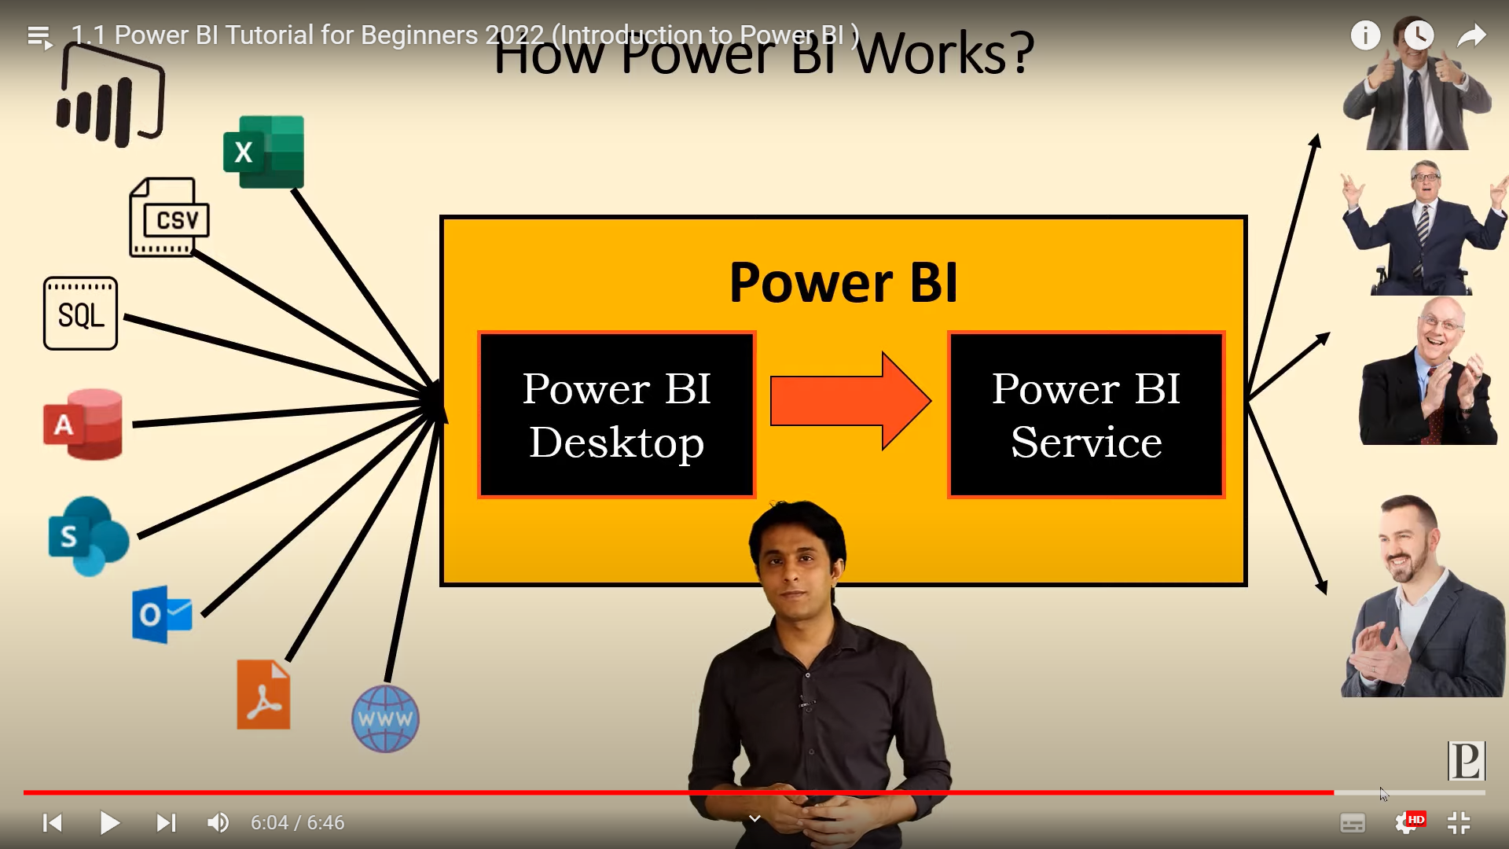 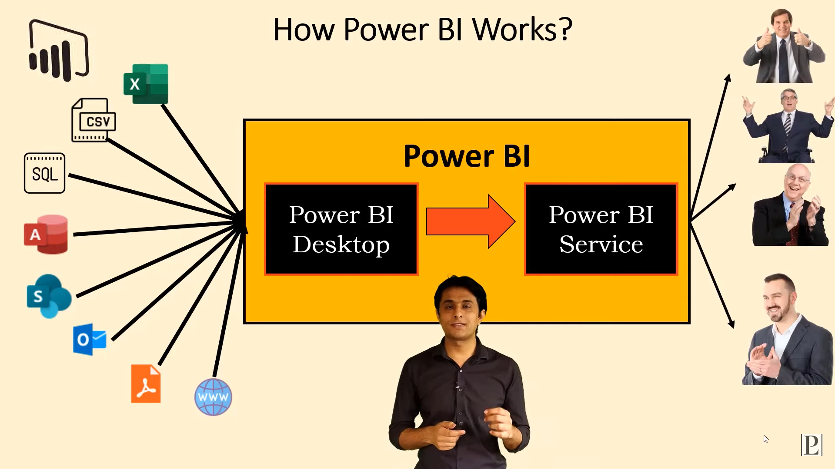

**Gathers Data do the Work** **Gathers client**

**and publishes the work**

**How to Download, Install and upgrade features in Power BI**